Applied Analytics Practicum - Enverus

**Team 5**

hdupouy3@gatech.edu  
oalmansour3@gatech.edu  
[jgarcia340@gatech.edu](mailto:jgarcia340@gatech.edu)

***Abstract***

This project presents a study to evaluate the impact of various locations and modeling techniques on predicting solar farm energy generation's performance. This research project was undertaken in collaboration with Enverus, an energy technology company renowned for its innovative software, data, and services in the energy market. This study compares and contrasts different modeling options by incorporating location-specific source data and alternative modeling techniques. This paper discusses the investigation's problem statement, objectives, and desired goals.

# Introduction

## 1.1. Enverus

Enverus, an energy technology company, is the driving force behind this research endeavor. Since its establishment in 1999, Enverus has emerged as a prominent provider of energy market data, analytics, and technology solutions (Enverus, 2023). With a commitment to optimizing operations and fostering a deeper understanding of energy markets, Enverus offers innovative software, data, and services to facilitate informed decision-making within the energy sector. Indeed, Enverus gives energy firms the platforms, tools, and applications they need to be adaptable and thrive in a challenging and changing market environment. Additionally, Enverus provides invaluable services such as expert guidance, data analysis, and market intelligence, further solidifying its position as a leader in the field.

## 1.2. Objective

### 1.2.1. Project objectives

This project's primary objective is to study the effect of incorporating location-specific source data and various modeling techniques to predict energy generation performance from solar farms. We will compare and contrast several models in an effort to improve energy generation in a specific location. This will be achieved through extensive research and experimentation. Enverus will provide us with an anonymized dataset. This dataset contains the target variable and timestamps extracted from California ISO toward the actual solar megawatt generation (California ISO, 2023). This research will contribute to the existing literature on the prediction of the energy generation performance of solar farms, and it will also assist energy companies like Enverus in making informed decisions in order to thrive in the ever-changing energy market.

### 1.2.1. Value and Magnitude

This project holds substantial value for the company by generating valuable insights and knowledge concerning the prediction of energy generation. By integrating location-specific source data and advanced modeling techniques, the project aims to enhance solar farm performance models' accuracy and predictive performance. By improving the precision and reliability of these models, energy companies can make more informed decisions regarding their operations, resource allocation, and identification of regions with high solar energy generation potential. This optimization of processes and resource utilization can lead to cost savings and overall performance improvements, enabling companies to stay competitive in a rapidly changing market.

The magnitude of this project is noteworthy due to its comprehensive approach and incorporation of multiple elements. This project requires external data and time-series forecasting models to produce predictions. Based on the combination of the data provided and retrieved, it needs to leverage machine learning models and visualization libraries. Indeed, the scale of the project involves analyzing a substantial amount of data, with up to 50,000 rows and 20 input variables per data source. Furthermore, advanced modeling techniques, such as Random Forest and eXtreme Gradient Boosting (XGBoost), capture complex relationships and patterns within the data. The project also includes a thorough review of relevant literature on solar generation forecasting to incorporate best practices and industry knowledge. Given the comprehensive nature of the project and its potential impact on decision-making processes within energy companies, the magnitude of this endeavor is significant.

## 1.3. Problem statement

Existing methods for forecasting solar farm performance have limitations due to a lack of consideration for location-specific data and reliance on traditional modeling tools. This leads to inaccurate and unreliable predictions. To address this issue and improve the accuracy and foresight of solar farm performance models, evaluating and comparing the outcomes obtained by utilizing location-specific data sources and advanced modeling methodologies is necessary. By doing so, energy providers can enhance operational efficiency, optimize resource allocation, and identify areas with the highest potential for solar power production.

Research questions:

• When comparing generic data sources and traditional modeling methods to solar energy-generating performance prediction, how does integrating location-specific data sources and sophisticated modeling techniques affect the accuracy and predictive performance?

• Moreover, how might these enhancements help energy firms maximize operations, allocate resources, and pinpoint areas with the most significant potential for solar power generation?

## 1.4. Hypotheses

Our first hypothesis mentioned that location and modeling methods affect solar farm performance. Using location-specific source data, which accounts for physical closeness to the place under investigation, the models should reflect various locales' distinctive traits and variances. Solar irradiance, weather patterns, topographical characteristics, and environmental factors may be included. This study's design matrix includes data from nearby macro, meso, and microregions. This study aims to solve research questions and understand solar generation performance aspects.

Indeed, this hypothesis also predicts that sophisticated algorithms like Random Forest, XGBoost, and others can capture complicated linkages and nonlinearities in data. These methods may reveal patterns and relationships that linear regression models miss. By merging advanced modeling approaches with location-specific data sources, solar farm performance projections will be more precise and dependable. This helps energy businesses optimize operations, allocate resources, and find solar energy-generating zones.

The study will investigate numerous data sources and model classes to test our notion. If considerable gains are found, the models' accuracy, robustness, and generalizability will demonstrate the suggested approach's usefulness.

# Literature review

In our specific study, the geographical location under investigation is within the California region. However, it is important to acknowledge that the exact geographical location within California plays an important role in the performance of solar farms, as pointed out by Miao, Ning, Gu, Yan, and Ma (2018). These authors highlight the variability of solar radiation across different locations and propose a comprehensive framework that considers factors such as latitude, longitude, and weather patterns to assess their impact on energy generation. The results of their research highlight significant differences in performance depending on the specific geographical location, further emphasizing the need for accurate modeling techniques (Miao, Ning, Gu, Yan, & Ma, 2018). Therefore, for our project, we will strive to identify a precise location within California that allows for robust data analysis and the use of valued data science techniques for predicting time series data.

Solar power generation is influenced by several environmental factors, as highlighted by Singh and Singh (2021). These factors include solar irradiance, temperature, humidity, dust, shading, and wind speed. In addition, the technical design characteristics of photovoltaic cells, such as the materials used in their manufacture, also affect the power generation capabilities of the cells (Chikate & Sadawarte, 2015). Therefore, we don't have access to photovoltaic cell specifications in our data collection process. However, we aim to collect additional data points in order to obtain a comprehensive overview of all significant factors affecting the performance of solar energy generation.

Similar studies in the field of solar energy generation have consistently emphasized the need for robust modeling techniques. Hobbs et al. (2022), in their research of probabilistic solar prediction using the probabilistic Watt-Sun model, underlined the need for a reliable and accurate model despite the inherent uncertainties associated with prediction predictors. Similarly, Aksoy and Genc (2023) proposed an ensemble model that combines several basic models, such as Random Forests and Gradient Boosting Machines, to improve the accuracy of energy production forecasts. Their research demonstrates the effectiveness of ensemble learning in capturing complex relationships between input variables and energy production (Aksoy & Genc, 2023).

# Methodology

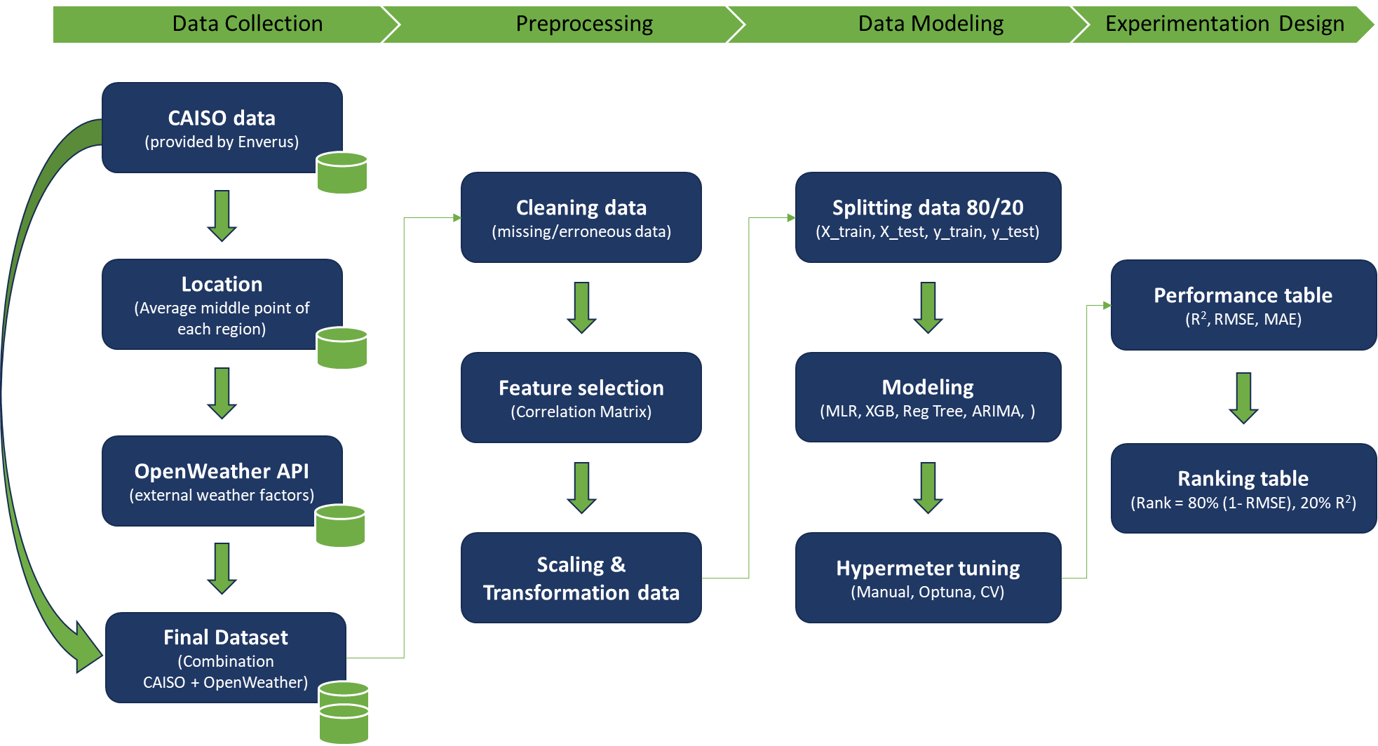For this study section, we have implemented an extract, transform, and load (ETL) data pipeline, as depicted in Figure 1. The ETL process is crucial for collecting, preparing, and organizing the data to ensure its suitability for analysis and modeling.

Figure 1. ETL Data Pipeline

## 3.1 Data Collection

The data collection process for this project involves gathering relevant information to assess the impact of geographical locations and modeling techniques on the prediction of solar energy generation's performance.

Firstly, we will need to understand the supplied data. As part of our collaboration with Enverus, we have been provided a simplified dataset of timestamps and an actual measure of megawatts generated (Appendix A). This 'Actual' measure is based on an average of the three main regions of California. Consequently, as this measure is an average location of the three main regions, we will have to determine a specific location to retrieve future data. In this case, we will take the middle location for each region based on latitude and longitude and will make an average of those coordinates to obtain our central point of California. This process will allow us to coordinate with the data provided by Enverus.

After defining California's middle point location, we will identify and select appropriate data sources that provide environmental factors towards weather factors (temperature, humidity, dust, shading, and wind speed). In this regard, we will use the specific location data from OpenWeather to join it to Enverus' provided data (OpenWeather, 2023)(Appendix A). This full dataset will represent 26185 rows and 31 columns.

Indeed, we will attempt to maintain a high level of data quality in this process. To ensure the reliability and integrity of the collected data, we will perform quality assurance with checks. This includes verifying data sources, checking for missing or erroneous data points, and addressing any data inconsistencies or outliers. Any necessary data cleansing or corrections will be carried out to improve the overall quality of the dataset.

## 3.2 Preprocessing

Data preprocessing is a critical step in preparing the collected data for analysis and modelling for our study.

We will start the explanatory data analysis by cleaning the data. Any missing, erroneous, or inconsistent data points identified during the data collection phase will be addressed. Missing values may be imputed using appropriate techniques, while erroneous or inconsistent data points are corrected or removed based on predefined criteria.

Then, we will proceed with feature selection. We will analyze the full dataset to identify relevant features that contribute significantly to predicting solar energy performance. This step involves establishing a correlation matrix between variables, checking the numerical variables' density, inspecting the categorical variables' distribution, and using domain knowledge to select the most informative features for modeling.

Last but not least, we will proceed with imputation, feature scaling, and transformation. For our missing values, we will proceed with the imputation of the mean value in the numerical variables to avoid the instabilities in the predictions and increase our prediction accuracy (Thomas & Rajabi, 2021). Then, our features will require scaling or transformation to ensure compatibility and optimal performance, as machine learning algorithms can interpret only numerical data (Rebala, Ravi, & Churiwala, 2019). We will proceed with normalizing the numerical data and transforming the categorical data into dummy variable columns with the library Scikit-learn.

## 3.3 Data Modeling

Based on the preprocessed collected data, the data modeling phase focuses on developing models to predict solar energy generation performance.

Based on the study's objectives and the literature review findings, we will select a range of modeling techniques to explore. These will include traditional statistical models like multi-linear regression and machine learning algorithms. We will use the following models: multi-linear regression, random forests, eXtreme Gradient Boosting, autoregressive integrated moving average (ARIMA), and Autoregressive model.

Then, we will focus on model development. We will develop and train the models using the preprocessed dataset for each selected modeling technique. This includes partitioning the dataset into training and test subsets, optimizing model parameters, and evaluating model performance using appropriate evaluation metrics (e.g., root mean squared error, R-squared).

Additionally, we will design an evaluation of the models. The developed models will be evaluated using cross-validation techniques to assess their generalization performance and robustness. We will analyze and compare the predictive capabilities of the models based on the equation provided by Enverus. The final ranking of our models will be based on the following equation to determine the best model:

$$Final_Rank =\left[0.8 ∙ (1 - RMSE )\right]+\left[0.2 ∙ R^{2} \right]$$

## 3.4 Experimentation Design

The experimentation design phase focuses on setting up controlled experiments to compare and contrast different design options, taking into account geographical implications and modeling techniques. We will follow the process from the below graph.

Firstly, we will need to start with the design matrix. We will construct a design matrix containing data combinations from California CAISO and OpenWeather. These data sources will include macro, meso and micro regions in the vicinity of solar location. Then, we will split the dataset into a train and test datasets for both the response and the dependent variables for our models, corresponding to 80% and 20% respectively.

Then we will proceed with modeling. Indeed, the model classes will consist of a variety of modeling techniques such as multi-linear regression, regression tree, Seasonal Autoregressive Integrated Moving Average (SARIMA), and eXtreme Gradient Boosting (XGBoost). Here, we will have an experimental set-up phase. The team will be testing different parameters within the models to optimize them.

Lastly, we will design a performance comparison table based on the requirements from Enverus. The performance of the developed models will be compared and contrasted based on relevant evaluation metrics. This analysis will provide insight into the impact of different data sources and modeling techniques on solar performance prediction.

Through this comprehensive methodology, which includes data collection, preprocessing, data modeling, and experimental design, we aim to provide valuable insights into the impact of geographical locations and modeling techniques on the prediction of solar energy generation performance. This approach allows systematic analysis and comparison of different design options, contributing to the advancement of accurate and reliable methodologies in the field of solar energy prediction.

# Results and Visualizations

## 4.1 Linear Regression Modeling

The first model built was simple linear regression model using only the scaled GHI values. The purpose of this model is to be a reference model for assessing the performance of the upcoming more complex models. The dataset was randomly split into 80% training and 20% testing. The simple linear regression model achieved overall RMSE of 1744 MW, and R2 value of 85.2% on the testing set. However, these results are optimistically misleading because approximately half of the records in the dataset are within night time with zero power generation. This makes both the training and testing sets imbalanced with roughly half of the target feature values being zero. To overcome this issue, we can eliminate night time hours (zero production hours) which can be easily identified as described during data exploration phase. The night time hours are between 22:00 p.m. to 5:00 a.m. inclusive. After excluding night time hours, the simple linear regression model was fitted again. The model achieved overall RMSE of 1997 MW, and R2 value of 80.2% on the testing set, which confirms our doubts that keeping zero production hours may result in optimistically misleading results. A scatter plot of the predicted values versus actual power generation on the testing set suggests that simple linear regression model is not a suitable model for the power generation forecast problem (Figure-2). In addition, the error distribution of the testing set does not appears normally distributed which support the earlier observation that simple linear regression model does not fit to the data properly. Figure-3 & 4 show a comparison between actual and modeled solar power generation for a winter and a summer week in 2021 and 2022.

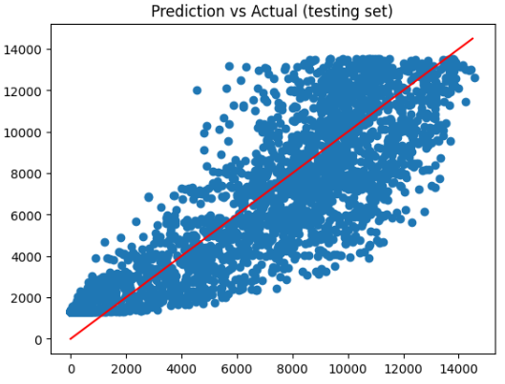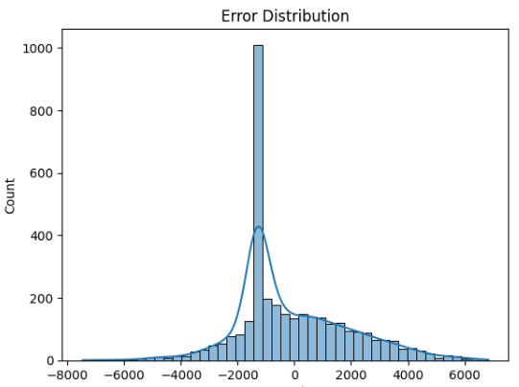

Figure-2. Prediction vs Actual; & error distribution for simple linear regression

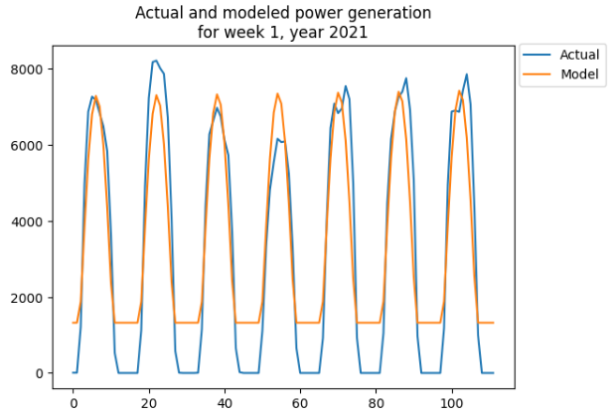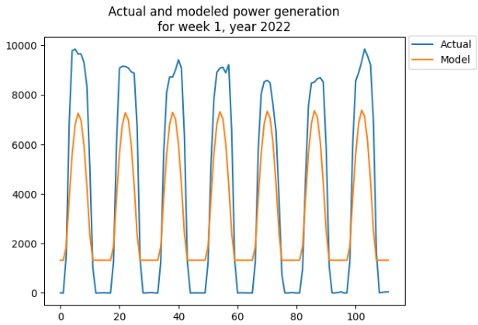

Figure-3. Actual and model power generation in a winter week in 2021 & 2022.

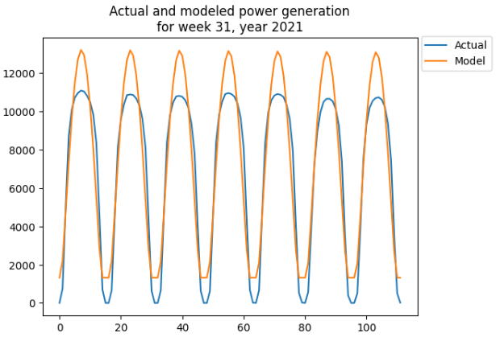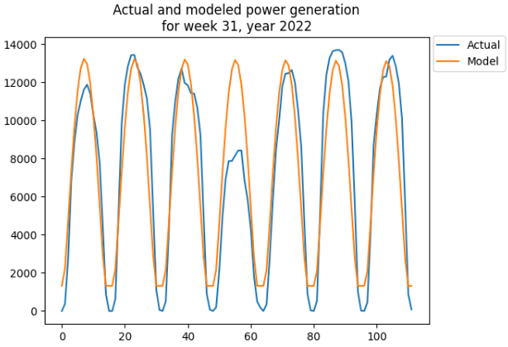

Figure-4. Actual and model power generation in a summer week in 2021 & 2022.

Next, we explored multiple linear regression model using the scaled numeric features of the whole dataset. Categorical features were excluded as their information is already captured in some of the numeric features. Also, we excluded night time hours as described earlier to avoid misleading results. Multiple model fit iterations were implemented while excluding one feature at a time to recognize the significant features. The first model utilizing all numeric features achieved RMSE of 1492 MW, and R2 value of 89.2%, while the final model utilizing only GHI and DNI was able to achieve RMSE of 1606 MW, R2 value of 87.2%. This suggests that both GHI and DNI are significant for forecasting power generation. A scatter plot of the predicted values versus actual power generation on the testing set suggests that MLR model yet is not a suitable model for the power generation forecast problem (Figure-5). In addition, the error distribution of the testing set does not appears normally distributed which support the earlier observation that MLR model does not fit to the data properly, although the model's predictive performance may be fair. Figure-6 & 7 show a comparison between actual and modeled solar power generation for a winter and a summer week in 2021 and 2022. Since regression models do not appear suitable, random forest models will be explored next.

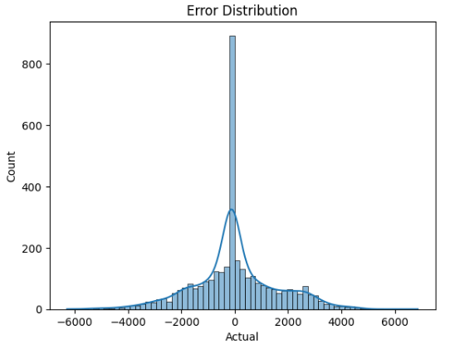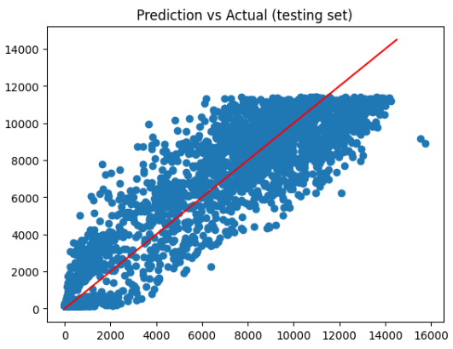

Figure-5. Prediction vs Actual; & error distribution for MLR model.

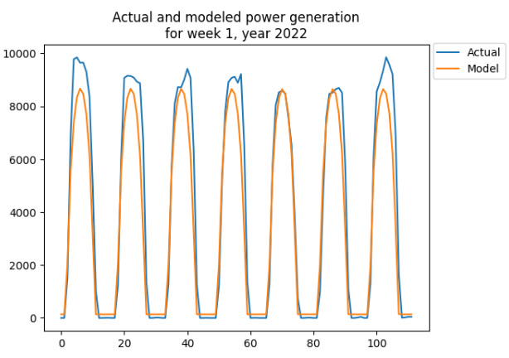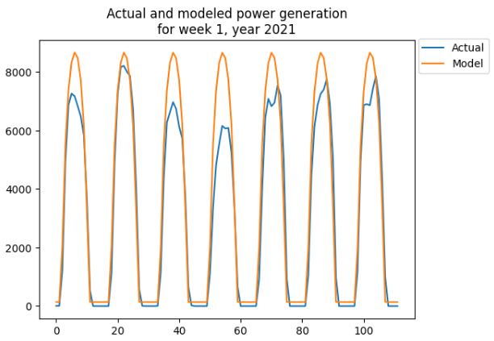

Figure-6. Actual and model power generation in a winter week in 2021 & 2022.

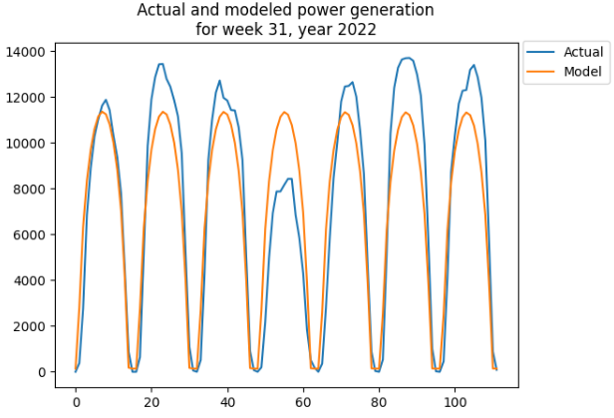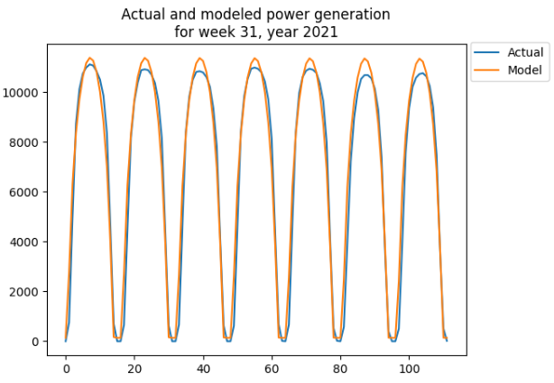

Figure-7. Actual and model power generation in a summer week in 2021 & 2022.

## 4.2 Random Forest

Random forest model was built using the scaled numeric features of the whole dataset. Categorical features were excluded as their information is already captured in some of the numeric features. The initial model was built with 100 trees and using the scaled numeric features. Next, multiple model fit iterations while excluding one feature at a time were implemented and assessed through R2 value and RMSE to recognize the significant features. The assessment revealed that GHI, DNI, cloud cover, humidity, pressure, and the week number are significant features. Next, the number of trees for the random forest model was optimized based on RMSE and R2 value as shown in Figure-8 below. The optimal number of trees was found to be 20, with overall RMSE of 1269 MW, and R2 value of 92.2% on the testing set. A scatter plot of the predicted values versus actual power generation on the testing set suggests that random forest model is a suitable model for the power generation forecast problem (Figure-9). In addition, the error distribution of the testing set appears approximately normally distributed which support the earlier observation that random forest model has an acceptable fit to the data. Figure-10 & 11 show a comparison between actual and modeled solar power generation for a winter and a summer week in 2021 and 2022, signifying the reasonable performance of the model.

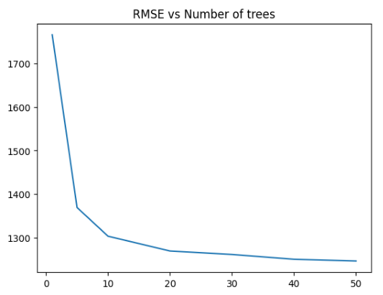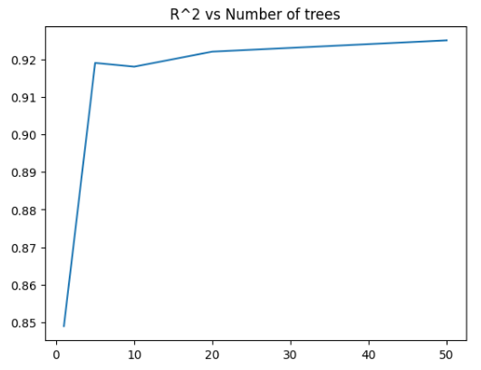

Figure-8. RMSE & R2 vs Number of Trees.

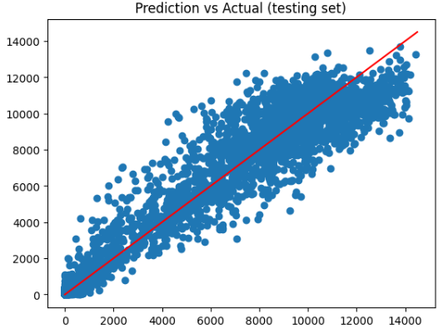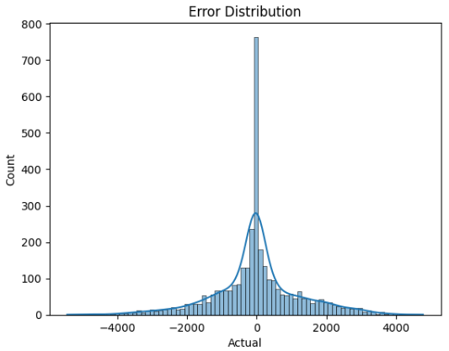

Figure-9. Prediction vs Actual; & error distribution for random forest model.

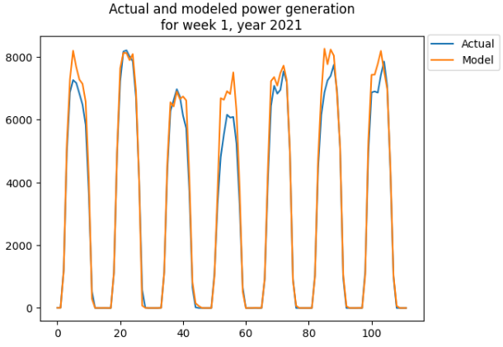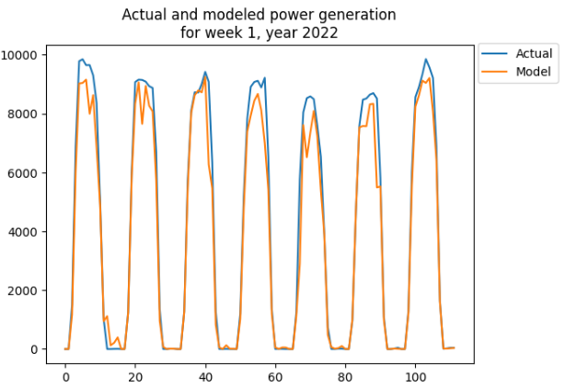

Figure-10. Actual and model power generation in a winter week in 2021 & 2022.

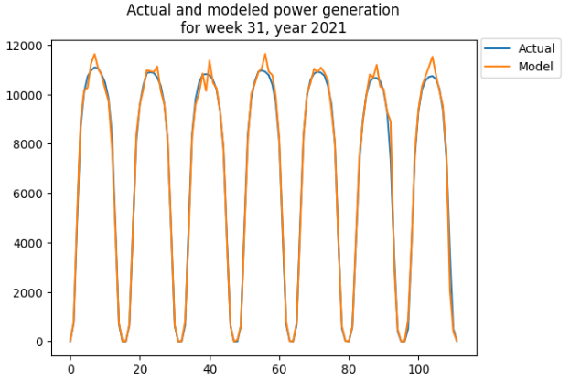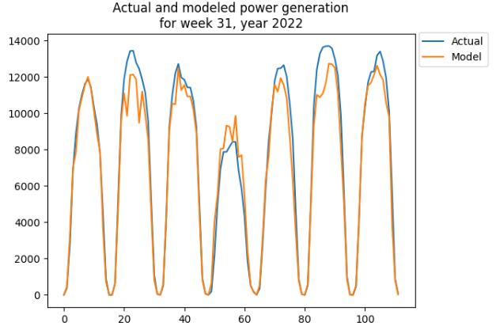

Figure-11. Actual and model power generation in a summer week in 2021 & 2022.

## 4.3 Time Series Modeling

Time series models were explored on the actual solar power generation without excluding night time. The auto_arima function was utilized to optimize the parameters p, d, q, comprising the order of the model. The function auto_arima suggested that the optimal order of Arima is (1,1,2). However, using this model order to forecast one week ahead revealed that it was poor as shown in Figure-12. Upon exploration, we noticed that only the autoregressive part of ARIMA model was the significant parameter, meaning that ARIMA model simplifies to autoregressive model. To identify the optimal number of lags in autoregressive model, we plotted the partial autocorrelation in the whole dataset as shown in Figure-13, and determined the optimal number of lags to be 74 hours. In order to maintain 80-20 train test split, the autoregressive model should be trained on 840 hours, to estimate the parameters associated with each of the 74 lags, in order to forecast the future 168 hours. The autoregressive model achieved an overall RMSE of 2015 MW, and R2 value of 76.9% which is the reference simple regression model. In addition, time series models lack explainability, which is important for the forecast problem. Consequently, autoregressive models or in general, time series models may not be suitable for the power generation forecast problem. Figure-14 shows the forecast performance of the 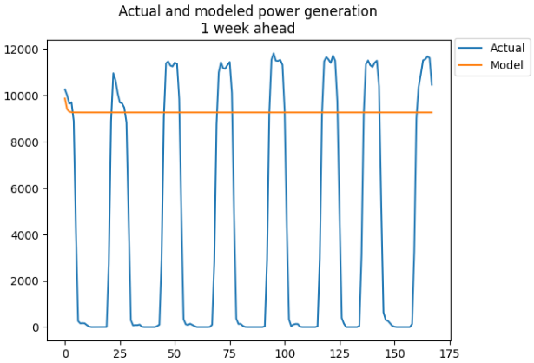autoregressive model in 2 different weeks, signifying the weak performance of the model.

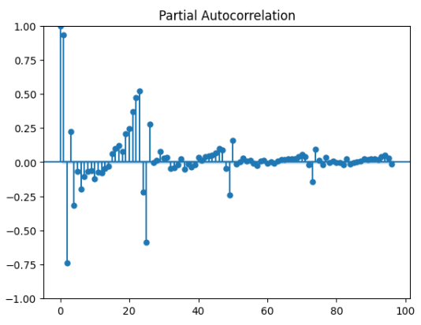

*Figure-11. Actual and modeled power generation. Figure-12. Autoregressive partial utocorrelation.*

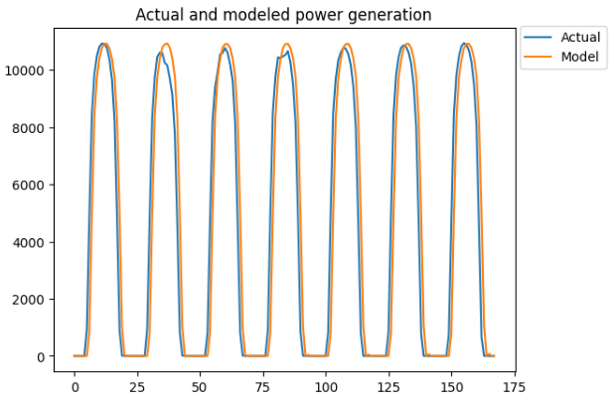 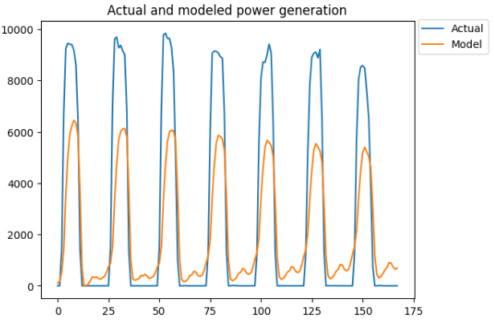

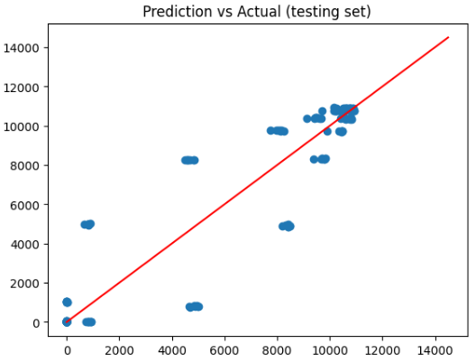 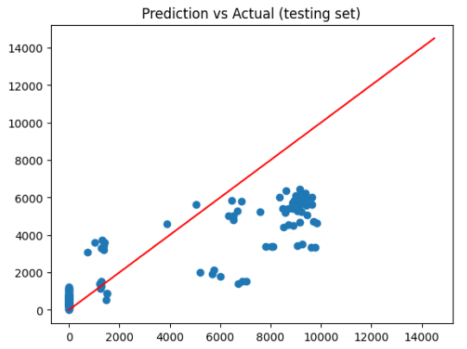

Figure-13. Autoregressive model performance in 2 different weeks.

# Conclusion and discussion

# References

Aksoy, N., & Genc, I. (2023). Predictive models development using gradient boosting based methods for solar power plants. *Journal of Computational Science, 67*(101958), 1-10. doi:https://doi.org/10.1016/j.jocs.2023.101958

California ISO. (2023). *California ISO Open Access Same-time Information System.* Retrieved from California ISO: http://oasis.caiso.com/mrioasis/logon.do?reason=application.baseAction.noSession

Chikate, B. V., & Sadawarte, Y. (2015). The factors affecting the performance of solar cell. *International journal of computer applications, 1*(1), 1-5. doi:0975 – 8887

Enverus. (2023). *Intelligent Connections*. Retrieved from Enverus: https://www.enverus.com

Hobbs, B. F., Zhang, J., Hamann, H. F., Siebenschuh, C., Zhang, R., Li, B., . . . Zhang, S. (2022). ISO, Using probabilistic solar power forecasts to inform flexible ramp product procurement for the California. *Solar Energy Advances, 2*(100024), 1-11. doi:https://doi.org/10.1016/j.seja.2022.100024

Miao, S., Ning, G., Gu, Y., Yan, J., & Ma, B. (2018). Markov Chain model for solar farm generation and its application to generation performance evaluation. *Journal of Cleaner Production, 186*(1), 905-917. doi:https://doi.org/10.1016/j.jclepro.2018.03.173

OpenWeather. (2023). *Weather API.* Retrieved from OpenWeather: https://openweathermap.org/api

Rebala, G., Ravi, A., & Churiwala, S. (2019). *Machine Learning Definition and Basics. In: An Introduction to Machine Learning.* Worldwide: Springer, Cham. doi:https://doi.org/10.1007/978-3-030-15729-6_1

Singh, A. K., & Singh, R. R. (2021). An overview of factors influencing solar power efficiency and strategies for enhancing. *Innovations in Power and Advanced Computing Technologies (i-PACT), 1*(1), 1-6. doi:10.1109/i-PACT52855.2021.9696845

Thomas, T., & Rajabi, E. (2021). A systematic review of machine leaning-based missing value imputation techniques. *Data Technologies and Applications, 55*(4), 558-585. doi:https://doi.org/10.1108/DTA-12-2020-0298

# Appendix A

Data provided:

OpenWeather data: